:: Vendor Package ::

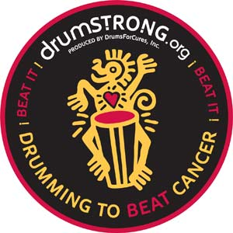

10th Annual DRUMSTRONG Rhythm & Arts Festival May 21, 2016
455 Providence Rd S. & Ennis Rd, Weddington, NC 28173
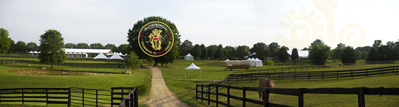

Thank you for your interest in our upcoming 10th Anniversary DRUMSTRONG Festival.
DrumsForCures produces DRUMSTRONG events globally raising awareness and funds in support of cancer education, research and survivorship :: through Rhythm.
Our annual Rhythm & Arts Fest main event takes place in the rolling pastures of Misty Meadows Farm in Weddington, North Carolina just 4 miles south of HWY485 on Providence Rd.
World Class Artists perform on stage, Art, Food, Health Resource Expo, Disc Golf, KidZone and fun Activities abound with a YogA Thon & 12 hour non-stop DrumCircle to BEAT cancer! Smiles and Good Intentions encouraged.
Projected Statistics :: Expected Attendance :: 3,000+.
Projected Demographic :: 18 to 21 = 15%, 21 to 25 = 15%, 25 to 30 = 25%, 30 to 40 = 25%, 40 plus = 20% + Families

Vendor Package - Donation to DrumsForCures 501c3 - $200. Includes ::
- 2 General Admission - Logo & link on Website – sponsored posts on our Facebook Pages, promotional tweets about your organization on twitter - power drop provided
Vendor Package (non profits) - Donation to DrumsForCures 501c3 - $100. Includes ::
- 2 General Admission - Logo & link on Website – sponsored posts on our Facebook Pages, promotional tweets about your organization on twitter - power drop provided
Vendor Package (Food Service) - Donation to DrumsForCures 501c3 – $225. Includes ::
- 2 General Admission - Logo & link on Website – sponsored posts on our Facebook Pages, promotional tweets about your organization on twitter - power drop provided
We're very flexible and will work with your needs. Please don't hesitate to help us customize your experience and let us know as soon as possible that you will be joining us in the pastures for the most uplifting and joyous festival on the planet. www.drumstrong.org
You can pay via PayPal at scott@drumstrong.org or send check to ::
DRUMSTRONG
725 Providence Rd. #210
Charlotte, NC 28207
We encourage you to donate at least 15% of sales to DrumsForCures 501c3.
You will need to provide your own 9x9 or 10x10 Tent (attractive, sturdy, and securely staked against any windy weather, accessible, with at least a back wall), table(s), chair(s) and lighting. You must provide General Liability Insurance and a Certificate of Insurance with DrumsForCures, Inc and Misty Meadows Farm as named additional Insured.
Contact staceydrumstrong@gmail.com with any questions.
We look forward to an exciting, fruitful, inspirational and mutually beneficial event!
When confirmed, we will send further details.
Most sincerely,
Scott

